**Results for training BERT Relation Classification Model for the week 17th Oct – 21st Oct 2022**

**Work done on BERT REL from 17th Oct-20th Oct 2022**

1. (2*9+1)-Way Evaluation (Using Directionality)

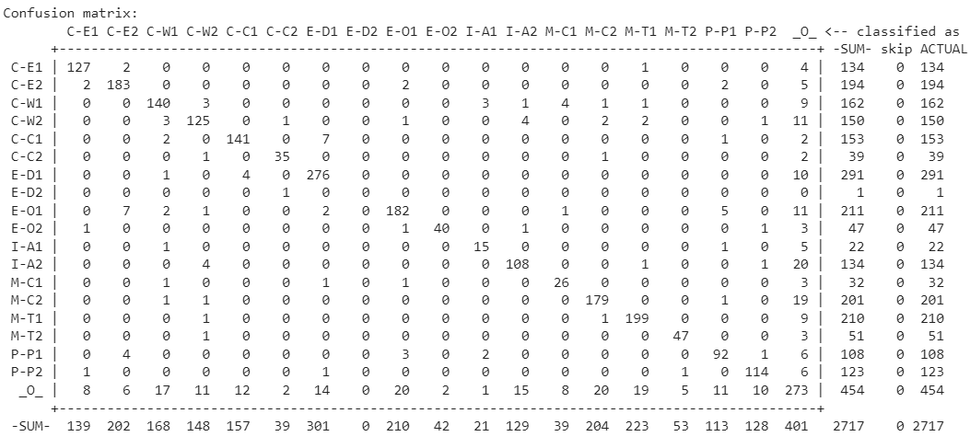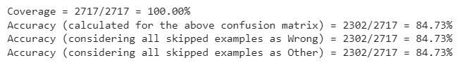

Performance Metrics of individual relations

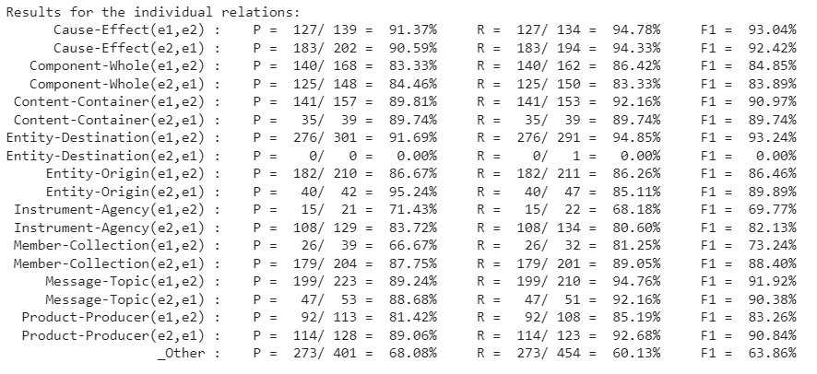

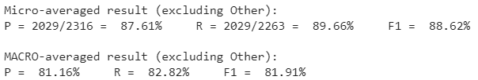

1. (9+1)-Way Evaluation Ignoring Directionality

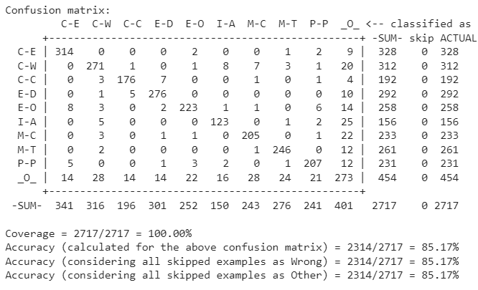

Performance Metrics of individual relations

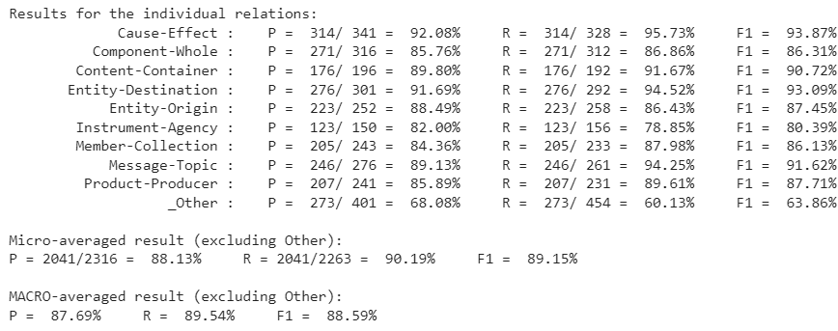

1. (9+1)-Way Evaluation Taking Directionality into Account – Official

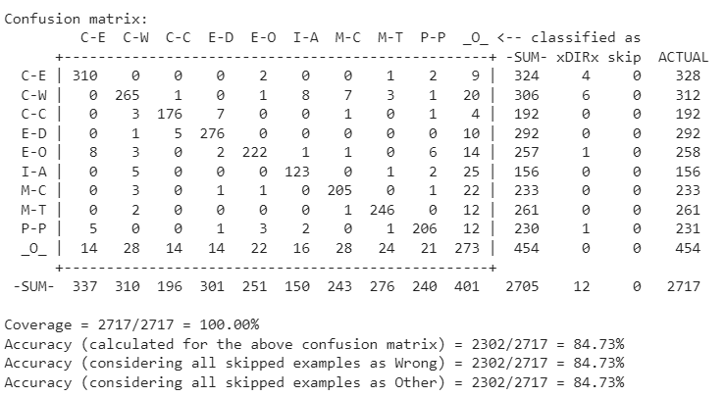

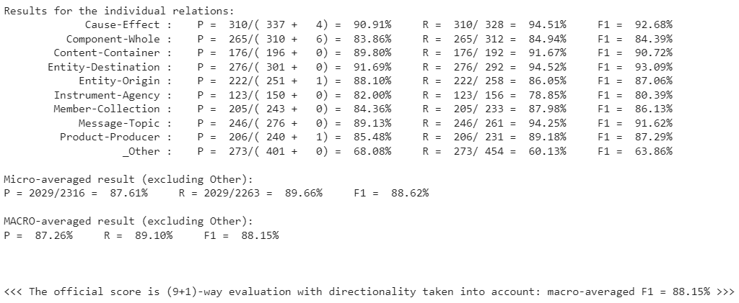

**21st October 2022**: Working and exploring the py-sec-edgar repository for SEC filings. (https://github.com/ryansmccoy/py-sec-edgar)